VOLCANO PROJECT

Parts of the Project: (This project counts as 2 test grades)
- Create a 3 dimensional poster of the inside of a volcano
- Give an in-class presentation of project
Requirements for the 3-D Poster: 60 points total
(60 points)
_____ Visual must be large enough for entire class to see
(ex. on poster board)

_____ Title of the visual must be present and spelled correctly (specifying the type of volcano drawn)

_____ Choose a real life example of the specific kind of volcano and provide information about it somewhere on the poster (may include a picture of the volcano)

_____ Diagram drawn is of the INSIDE of the specific volcano you choose

_____ Display each part of the volcano with materials that stick out from the poster– any materials can be used to do this EXCEPT edible materials

The following parts of the volcano should be labeled and spelled correctly on the poster:
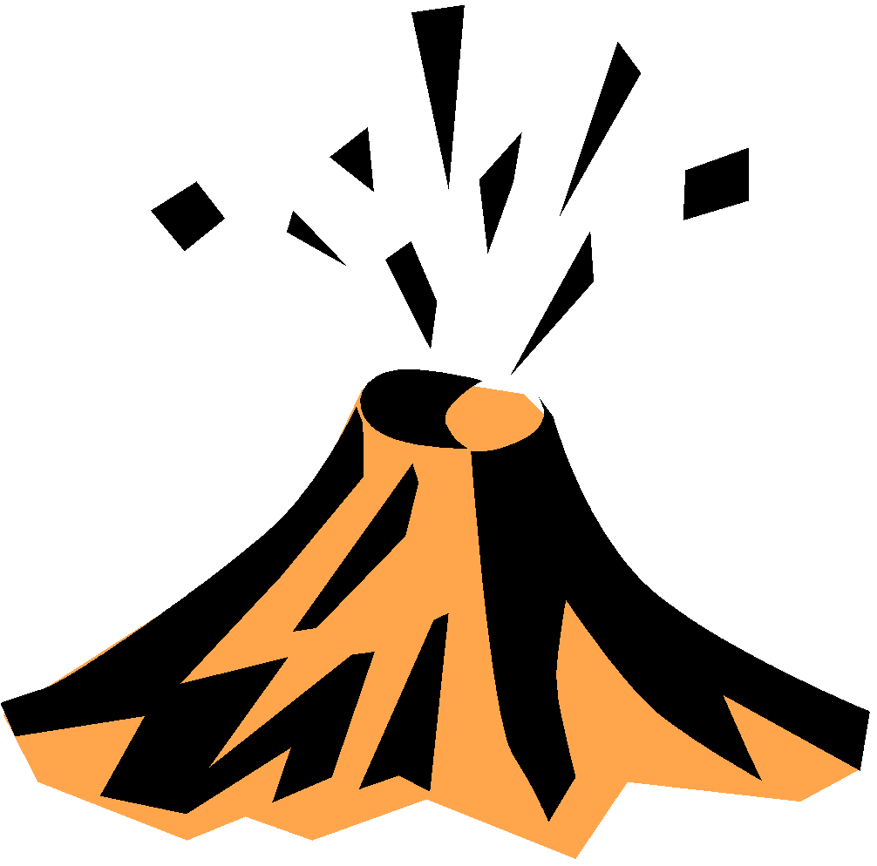
_____ 1. ash/gas
_____ 2. magma chamber
_____ 3. central vent
_____ 4. vent
_____ 5. crater
_____ 6. sill
_____ 7. dike
_____ 8. lava, tephra, or both lava and tephra (this depends on the type
of volcano chosen)
_____ 9. Title/type of volcano
_____ 10. Real time example
Requirements for presentation: 40 points total
_____ All visuals are shown during presentation

_____ Visuals are accurately explained during presentation (what everything is and how it was made)

_____ Information about a real life example of the specific
kind of volcano is shared and explained with students

_____ Be able to answer any questions the teacher may have about your poster and/or chosen real life example volcano.
IMPORTANT:
***YOU MUST TURN IN BOTH RUBRICS WITH YOUR PROJECT – IF YOU DO NOT, 5 POINTS WILL BE DEDUCTED FROM YOUR GRADE.***
***10 POINTS OFF EVERY DAY YOUR PROJECT IS LATE.***
Due Date Monday, March 16th Assigned Tuesday, February 17th 27 Days to work

